Experiment- 9:
OBJECTIVE:
• To formulate a continuous-time LTI system from a differential equation, obtain its transfer function under zero initial conditions, simulate impulse and step responses, and relate the system poles to its transient behaviour and stability.

Software / Laboratory Environment :
MATLAB
Matlab Coding:
clc;
clear;
close all;
% Continuous-Time LTI System
% dy(t)/dt + 2y(t) = x(t)

% Transfer Function
num = [1];
den = [1 2];
sys = tf(num, den);
disp('Transfer Function:');
sys
disp('Pole:');
disp(pole(sys));
disp('Zeros:');
disp(zero(sys));
% Time vector
t = 0:0.01:5;
% Impulse Response
figure;
impulse(sys, t);
grid on;
title('Impulse Response');
xlabel('Time (s)');
ylabel('h(t)');

% Step Response
figure;
step(sys, t);
grid on;
title('Step Response');
xlabel('Time (s)');
ylabel('y(t)');

% Response to sin(2t)u(t)
x = sin(2*t);

figure;
lsim(sys, x, t);
grid on;
title('Response to sin(2t)u(t)');
xlabel('Time (s)');
ylabel('y(t)');

OUTPUT:

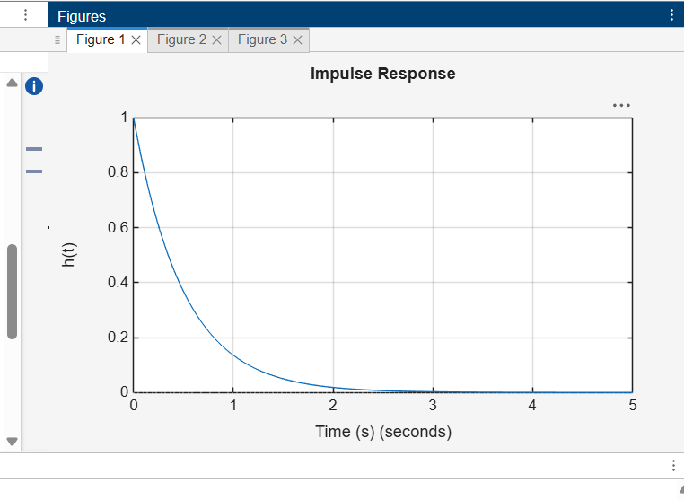

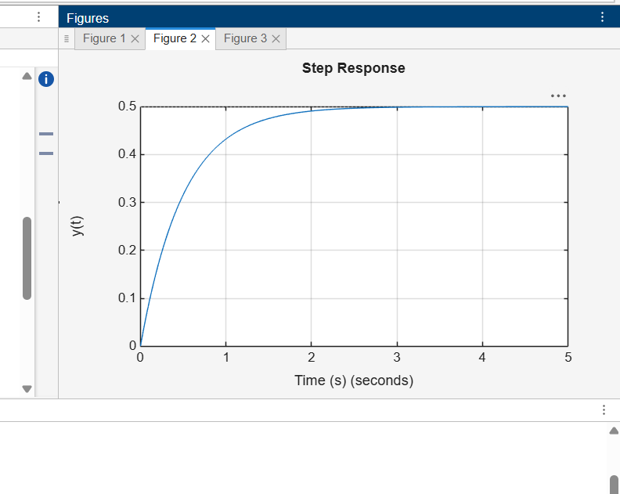
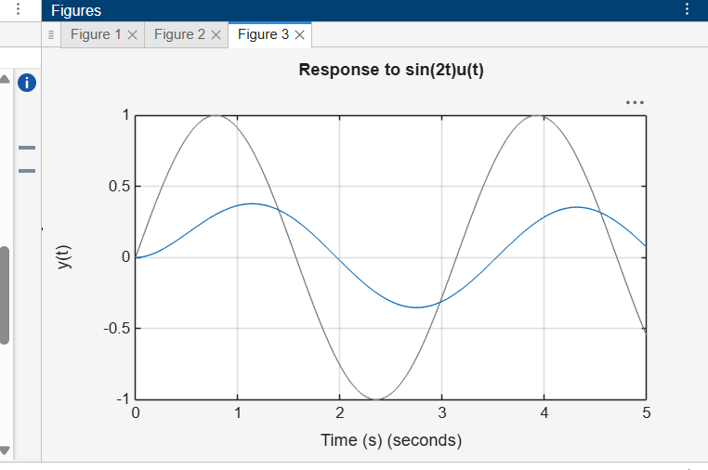

Conclusion:
The continuous-time LTI system was modeled from its differential equation, and its transfer function, impulse response, step response, pole locations, and stability characteristics were analyzed using MATLAB.

